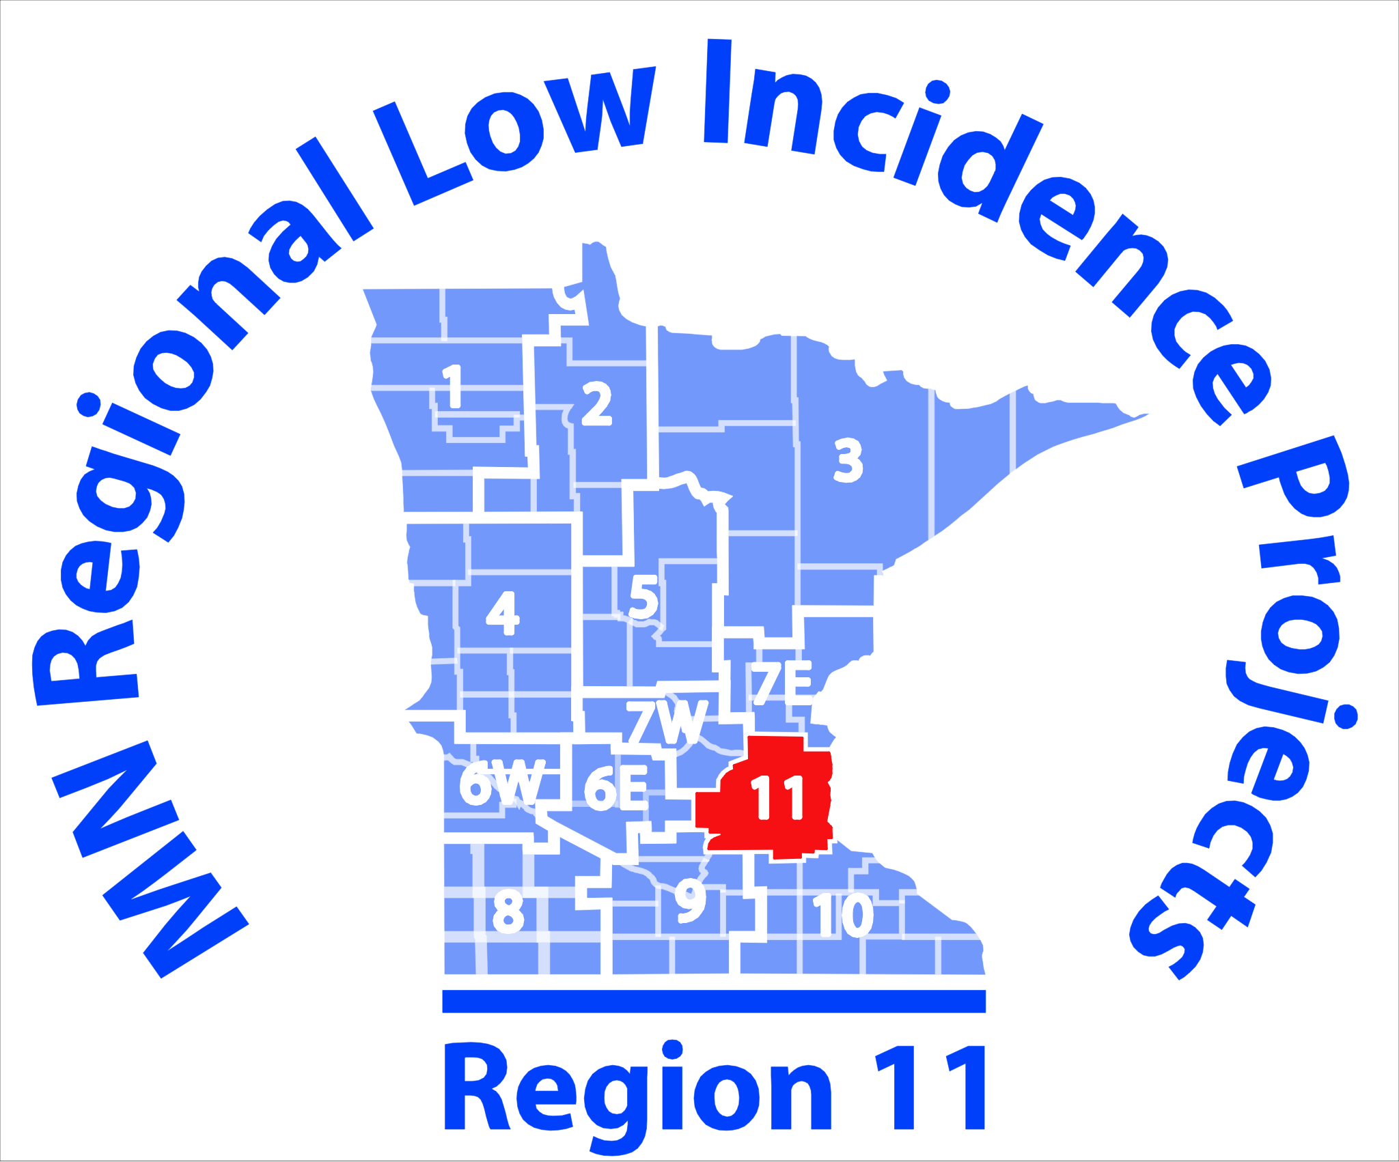
ASL Share Shop Community of Practice Agenda:

October 4, 2017
4:00-6:00 p.m.

Metro ECSU
Meeting Room
2 Pine Tree Drive
Arden Hills, MN 55112

Light meal provided
Workshop/Course Description: Participants will build on the information presented in past mentoring workshops and shareshops. We will examine the last round of EIPA results as they pertain to the Minnesota mentees from last year in an attempt to increase EIPA testing success. We will look for areas needing continued support and trainings and will set forth the plan for the upcoming year of workshops to foster continued professional growth not only for the non-certified but he certified as well. We will engage in discussion and planning for the mentors as to how to better adapt their mentoring style and materials to better prepare mentees for EIPA testing success. We will hear from the 3 delegates (Kay Pitney, Phyllis Genest-Stein, and Jay Fehrman) on their take away learnings from the Educational Interpreter Conference they attended this past June.
Educational Objectives:
• Identify Areas of concern still showing up on EIPA results and how to address them both in individual mentoring sessions as well as from a regional perspective.
• Will discuss, identify and gather tools with an opportunity for sharing of materials and strategies that each mentor is using and share for the benefit of all mentors
• We will gather information presented from the 3 delegates to the NAIE conference on how to effectively mentor and move forward our educational interpreters here in Minnesota.

Action Plan:
- Introduction of Share shop Attendees
- Presentation from the NAIE delegates (Jay, Phyllis and Kay)
- Gather district data on mentor/mentee numbers
- Gather EIPA result data as pertaining to Mn mentees from March 2017 testing
- Identify areas of weakness and discuss/plan continuing ed opportunities
- Dialogue on how to adapt mentoring to meet the needs of the remaining mentees

Note Taker: TBD

This initiative is made possible in whole with a grant from the Minnesota Department of Education using federal funding, CFDA 84.027A, Special Education – Grants to States.

This event does not necessarily represent the policy of the federal Department of Education or the state Department of Education. You should not assume endorsement by the federal or state government.

